HOMEWORK

1. Draw the shape corresponding to the Boolean expression

a, (x > 2 and x < 4) or (y < 2) 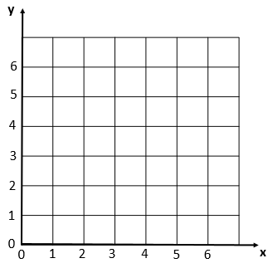

b, (x>2 and x<6) and (y>2 and y<6) and not(x>4)



2, Write the boolean condition for this grid

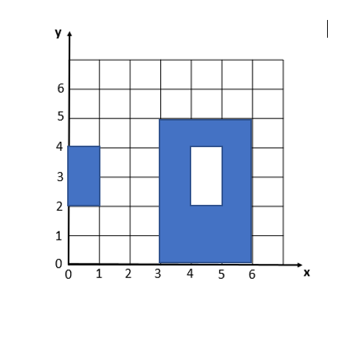

Expression:[(x>3 and X<6) and (y>0 and y<5) and not(x>4 and X<5) and y>2 and y<4)] or (X> and x<1) and (y>2 and y<4)

2. Demonstrate these equalities using the 9 simplification rules you have learnt:

* !(C and D) and (!C or D) and (C or !D) = !C

!(C and D) and (!C or D) and (C or !D) = !C

(!C or !D) and (!C or D) and ( C or !D)

!C or (!D and D) and ( C or !D)

!C or false and (C or !D)

!C or(false and C ) or ( false and !D)

!C or false or false

!C or false

!C=!C

* ! ( !C and (!B or !C) ) =C

![(!C and !B) or (!C or iC)]

![(!C and !B) or !C)]

![!C and (!B or True)]

!(!C and True)

!(!C)=C

* (A and B) or (A and !B) = A

A and ( B or !B)

A and True

=A

3.. What is the output of flowchart? If x=6 and y = 5 and z = 1

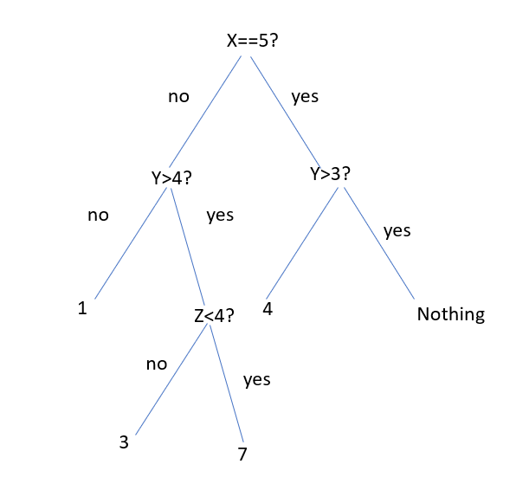

Answer 1->7

1. Draw the tree of conditions

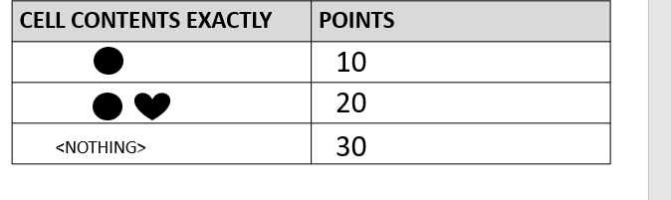

No Yes

Yes

No Yes No

30 0 10 20

1. Draw the tree of conditions

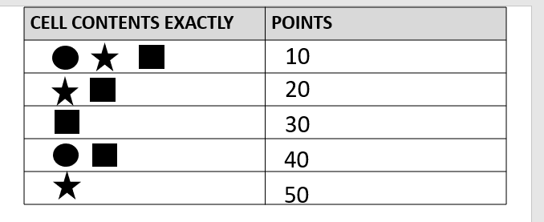

No Yes

Yes

No

No

Yes

Yes

No Yes

0 40

No 10

No Yes 0

0 30 50 20

1. Draw the tree of conditions

-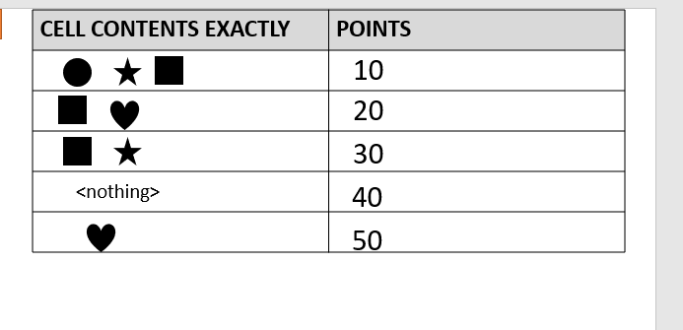

No Yes

Yes

No

Yes

No Yes

No

D

Yes YEs 10

0

No No

20

D

0

No No Yes

Yes

40 50 0 30

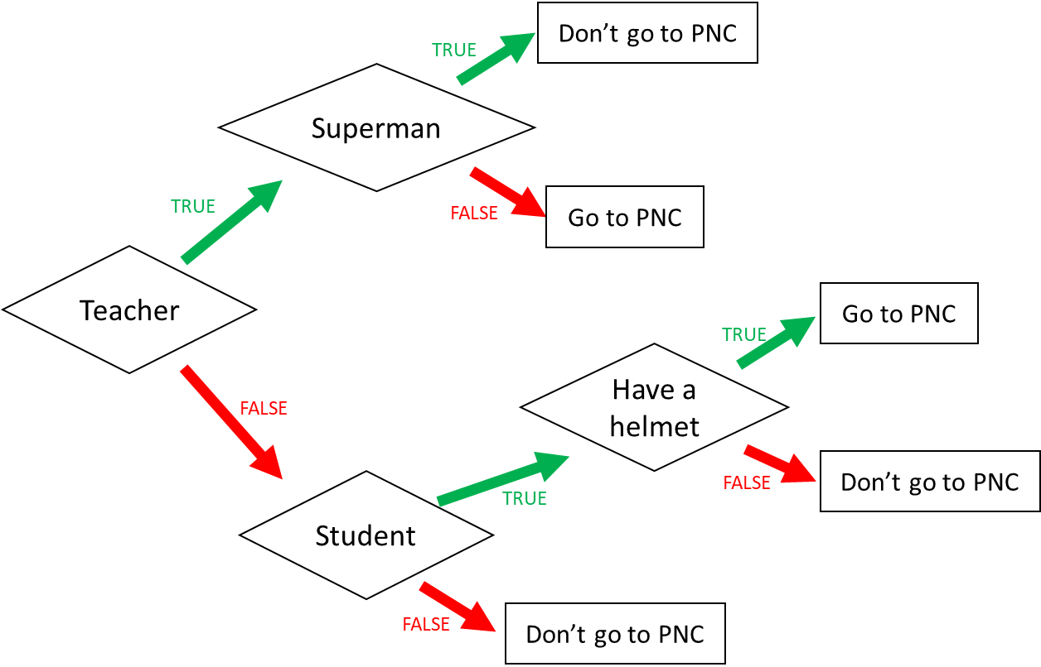

1. I am a teacher and I am superman, can I go to PNC? No
2. I am not a teacher and not a student, can I go to PNC? No
3. When can I go to PNC? (Express the condition using a Boolean expression)

I go to PNC if: (teacher and i’m not superman) or (i’m not teacher and student and Have a helmet)

8

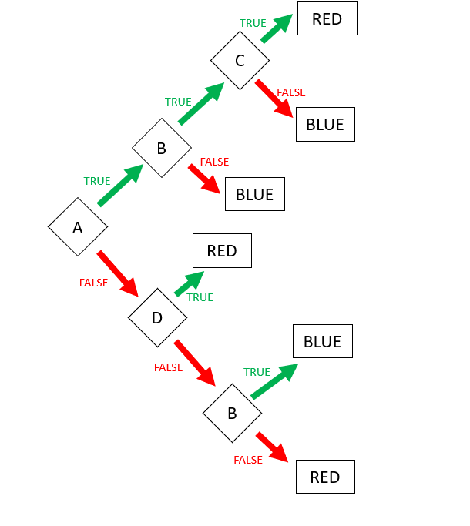

Expression: **RED** = ABC or !AD or !A!D!B

Expression: **BLUE** (FALSE) = A!B or AB!C

9. Encoding

* First 3 characters “MIX”, repeated many times (max repetition is 5)
* Then 1 character “!”, repeated many times (max repetition is 5)
* Then 1 number (0-3)

Examples:

MIXMIXMIX!1

MIX!!!!!3

MIXMIXMIX!!!2

**Q1**. Propose an **encoding** **structure** to encode this image.

|  |  |
| --- | --- |
| Encoding parts | Encoding values (in binary) |
| The repetition of text “Mix”: 1...5 | 001...101 |
| The repetition of character “!” 1...5 | 001...101 |
| The munber of end: 0...3 | 000...011 |
|  |  |

**Q2**. What is the total **size** of your encoding? Give explanations.

Encoding size:8bite

*Explanation:*

*Part1: 101 that mean text of Mix repeated 5 time*

*Part:101 that mean text of if ! repeated 5time*

*Part: 101 that mean number of at the is 3*

We want to encode **a text** following those rules:

* 3 letters: A, B, C
* The letters are always in the alphabetic order
* Letters are repeated from 1 to 10 times
  + Each letter is repeated the same number of times
* The last character must be either: X, Y, or Z

*Examples:*

|  |  |
| --- | --- |
| ABCZ | Good |
| AAAABBBBCCCCX | Good |
| AABBCCY | Good |
| AAABBBCCCX | Good |
| AABBBBCCX | Bad: letter A is repeated 2 times but letter B 3 times |

**Q1**. Propose an **encoding** **structure** to encode this image. (20pts)

|  |  |
| --- | --- |
| Encoding parts | Encoding values (in binary) |
| Leter of A 1..10 | 0001...1010 |
| Leter of B 1..10 | 0001...1010 |
| Leter of C 1..10 | 0001...1010 |
| The last leter X, Y ,Z 1...10 | 0001...1010 |

**Q2**. What is the total **size** of your encoding? Give explanations.

Encoding size:16bite

*Explanation:(6pts)*

*Part1: : 1010 that mean text of leter< A > repeated 10 time*

*Part2: 1010 that mean text of leter< B > repeated 10 time*

*Part2: 1010 that mean text of leter< B > repeated 10 time*

*Part2: 1010 that mean text of the last < X,Y,Z > repeated 10 time*